Exercise 5: Task Management System

Aim
To implement a Task Management System using a Singly Linked List and perform add, search, traverse, and delete operations.

Scenario
Tasks in a task management system should be managed efficiently as they are frequently added and removed.

1. Understanding Linked Lists
Singly Linked List: Each node contains data and a pointer to the next node. Memory efficient and easy to implement.
Doubly Linked List: Each node contains pointers to both previous and next nodes, allowing traversal in both directions but using extra memory.
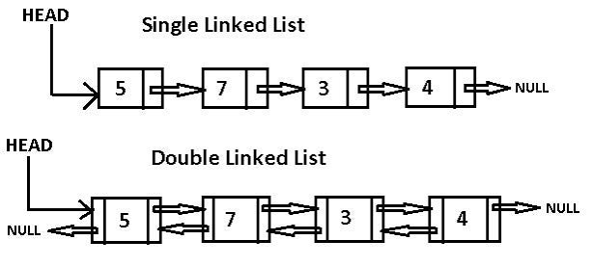

2. Setup
Create a Task class with TaskId, TaskName, and Status.
Software: Visual Studio / VS Code / .NET SDK

3. Implementation
using System;
class Task
{
public int TaskId;
public string TaskName;
public string Status;
public Task Next;
public Task(int id,string name,string status)
{
TaskId=id;
TaskName=name;
Status=status;
Next=null;
}
}
class TaskList
{
Task head=null;
public void Add(Task node)
{
if(head==null){ head=node; return; }
Task temp=head;
while(temp.Next!=null) temp=temp.Next;
temp.Next=node;
}
public void Search(int id)
{
Task temp=head;
while(temp!=null)
{
if(temp.TaskId==id)
{
Console.WriteLine(temp.TaskName);
return;
}
temp=temp.Next;
}
}
public void Traverse()
{
Task temp=head;
while(temp!=null)
{
Console.WriteLine($"{temp.TaskId} {temp.TaskName} {temp.Status}");
temp=temp.Next;
}
}
public void Delete(int id)
{
if(head==null) return;
if(head.TaskId==id){ head=head.Next; return; }
Task temp=head;
while(temp.Next!=null && temp.Next.TaskId!=id)
temp=temp.Next;
if(temp.Next!=null)
temp.Next=temp.Next.Next;
}
}

Sample Output
Tasks:
1 Design Completed
2 Coding In Progress
3 Testing Pending
Search Task 2:
Coding
After Deleting Task 2:
1 Design Completed
3 Testing Pending

4. Analysis

Operation | Time Complexity
Add | O(n)
Search | O(n)
Traverse | O(n)
Delete | O(n)
Advantages of Linked Lists over Arrays:
• Dynamic size.
• Efficient insertion and deletion.
• No need for contiguous memory.
• Suitable for frequently changing data.

Conclusion
The Task Management System was implemented using a Singly Linked List. Linked lists are well suited for dynamic applications where tasks are frequently added or removed, making them more flexible than arrays despite slower random access.

